**EECS 1012. Lab 2: HTML and CSS**

**A. IMPORTANT REMINDERS**

1) You should attend your own lab session (the one you are enrolled in). If you need to change your lab enrollment, you should go to the department. Instructors or TAs cannot change your enrollment. TAs are available via Zoom to help you during your lab hours.

2) You are required to pass the pre-lab mini quiz posted on eClass not later than the first 10 minutes of your lab time. You have 3 attempts; and you need at least 75% to pass. However, each time you may get some different questions. In addition to reading these instructions first, **make sure you do not start the pre-lab quiz unless you have done the pre-lab tasks (Section B below of this document)**. Failing the pre-lab mini quiz is equal to failing the whole lab.

3) You can also have your work verified and graded during the lab sessions. Feel free to signal a TA for help if you stuck on any of the steps below. Yet, note that TAs would need to help other students too. 4) Submit your lab work in eClass before the deadline. To pass this lab, your grade for it should be at least 70%.

**Important note:** this lab is more complex and time consuming compared to the previous lab; you need to attempt to complete as much of the lab as possible before attending your lab session. We do not accept late submissions. Email submissions receive a zero.

**B. IMPORTANT PRE-LAB WORKS YOU NEED TO DO BEFORE GOING TO THE LAB**

1) Download this lab description and the associated files and read it completely. Save the supplied files in a separate folder (directory) on your computer, name that folder Lab02.

2) Follow the following link for more understanding of CSS:

• Demo: https://www.w3schools.com/css/css_intro.asp

• Color picker: https://www.w3schools.com/colors/colors_picker.asp

• Complete list of font properties https://www.w3schools.com/cssref/pr_font_font.asp • Video on fonts: https://www.youtube.com/watch?v=yIVPuSyepX0

• Complete list of text properties https://www.w3schools.com/css/css_text.asp

• CSS Box Model: https://www.w3schools.com/css/css_boxmodel.asp

• HTML layout: https://www.w3schools.com/html/html_layout.asp

**C. GOALS/OUTCOMES FOR LAB**

1) To learn how to change the presentation of an HTML document using CSS,

2) To help you analyze an HTML page and decide how to modify it for a desired appearance using CSS.

**D. TASKS**

1) You are provided a simple diary.html document and corresponding images. Your job will be to adjust the presentation of the HTML content and structure in an iterative (step-by-step) fashion. 2) You will generate five HTML and CSS files in this process. When you decide to demo your work to the TA, please have each HTML file open in a different tab of your browser, so you can show the progression.

3) See the following pages for details on how to modify your HTML and CSS files.

**E. SUBMISSIONS**

1) Manual verification by a TA

You may want to have your TA verifying your lab before submission. The TA will look at your various files in their progression. The TA may also ask you to make minor modifications to the lab to demonstrate your knowledge of the materials. The TA can then record your grade in the system.

2) eClass submission

You will see an assignment submission link on eClass. Create a folder named “Lab02” (if you haven’t done so already) and copy all of your lab materials inside (image folder, diary_ex{1,2,3,4,5}.html and diary_ex{1,2,3,4,5}.css). This folder should be compressed (**zip** or **tar.gz**) and the compressed file submitted.

**F. STARTING POINT:** diary.html and images in the image folder.

You are given the following HTML file and associated images. This file has no CSS file. The lab task is to adjust the *presentation* of this HTML document by modifying the HTML slightly at each iteration and creating associated CSS files. We will do this step by step so you can see the process.

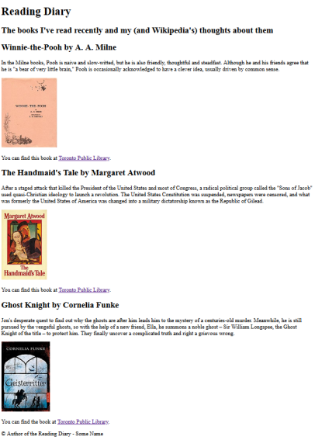

**Exercise 1: (**CREATE: **diary_ex1.html** and **diary_ex1.css)**

Try to match the output below as closely as possible – see the annotation for details. This exercise is to set up the basic HTML structure to assist in further modification. The associated CSS is to help you see how the item flow in the document. You need to organize the HTML content by adding in ids, classes, and associate these with <spans> and various <div>. This requires you to modify the HTML page to add in these new elements. In your CSS, create the corresponding *selectors* to set the borders to have a color and border (make it at least 2 pixels thick). The intent of this exercise is to to help you visualize the layout of your sections created using div, span, and classes.

1) Place a blue border around 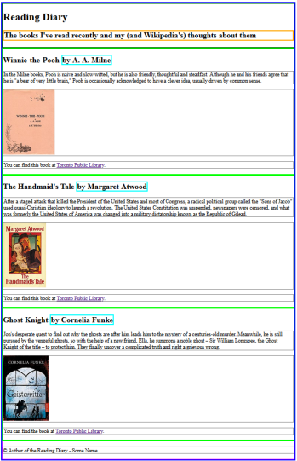

all content; add a div

**class="content"** for this.

don’t use id or class for 2 and 3

2) The header of the page should

have a green border.

3) The “The books I've read…” (that

is in h2 element) should have its

own border that is orange.

4) Each diary entry should

have a lime border.

don’t use id or class for 5

5) The “by <author name>”

within these entries should

have a cyan border (consider

span element).

6) All *paragraphs* should have

a thin grey border. This is so

you can see the page flow.

Note, all images should be

within <p> elements.

7) Bottom (footer) should

have a magenta border.

**Exercise 2**: **(**CREATE: **diary_ex2.html** and **diary_ex2.css** by copying from Exercise 1.**) NOTE**: The only change to diary_ex2.html is that it links to diary_ex2.css instead of diary_ex1.css.

i) Modify the CSS based on the annotations on the right. ii) Pay attention to the difference between *margin* and *padding*. iii) Use the rgb(-,-,-); notation for the color property in your CSS.

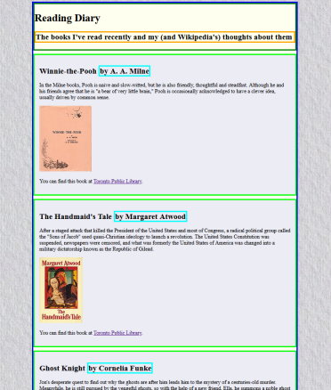

1) Make the body of the HTML page to have a background of 

“paper.png” (provided).

Add a left and right

margin of 10% to all of the main content.

2) Change the div 

around all the elements (the one with a blue

border) to have an ivory background.

3) Change all the 

entries (all items with a lime border) to have the following background color:

R=236, G=236, B=245

You should also add

padding of 15px and a top-margin of 10px.

(Note the difference between padding and margin)

4) comment out

paragraph borders.

**Exercise 3**: **(**CREATE: **diary_ex3.html** and **diary_ex3.css** by copying from Exercise 2.**)**

This exercise will change the alignment of elements using float, overflow, and alignment attributes in the CSS. This should be possible without editing the main HTML page (other than the link to the new CSS). See the annotations for the changes to make. Your webpage should look as close as possible to below.

The heading text in the 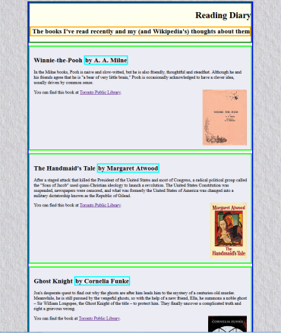

green box should appear

on the right side of that

section of the page.

The journal entries’ images

should **float** on the right

side next to the

surrounding text. The

images should stay within

the bounds of the blue

box; that is, they should

not bleed into the other

content below them. You

may need to use the

“overflow” attribute to

make the float elements fit

correctly.

**Exercise 4: (**CREATE: **diary_ex4.html** and **diary_ex4.css** by copying from Exercise 3.**)**

This exercise will finish the webpage. This last iteration makes small cosmetic adjustments to the border and colors. Again, you will not need to modify the HTML file other than linking in the new CSS.

Change all fonts in the 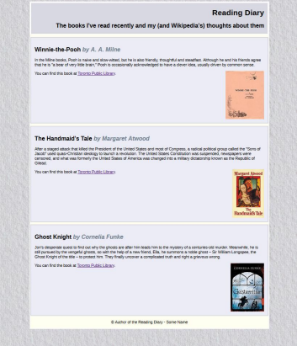

HTML document to a

better font (sans serif) of

your choice.

Change border to white.

Make the background

R=216, G=216, B=225

Change entries border to

R=216, G=216, B=225

Change the author info to

be in italics, slate grey

Remove border of footer

and align the text to the

centre.

**Exercise 5 (advanced layout):**

This last exercise is to modify your HTML and CSS to add in a *nav section* (LINKS) to your website or width 196px. The colour of this section can be the same as the entries (that is, Book 1, Book 2, Book 3, … ); hence, don’t rewrite the styling just use the one for entries. Note that you’ll have to consider how to make the section such that the entries adjust correctly as shown below. Try to make your webpage look as close as possible to the one below.

In the navigation section, add the following HTML code:

 <h2>Links</h2>  <ul>  <li><a href="https://www.torontopubliclibrary.ca/">TPL</a></li>  <li><a href="https://www.blogto.com/bookstores/">Bookstores</a></li>  <li><a href="https://www.boredpanda.com/parents-share-tips-tricks-to-make-kids read/">Parents Hints</a></li>  </ul>



**G. AFTER-LAB TASKS (THIS PART WILL NOT BE GRADED)**

Revisit each of the new HTML tags as well as CSS statements and properties that you used them in this lab via https://www.w3schools.com/ and explore more features about them.